Phase 1: Prepare the sheets

- Open New Google Spreadsheet

- Create New Google Spreadsheet with sample data as shown below

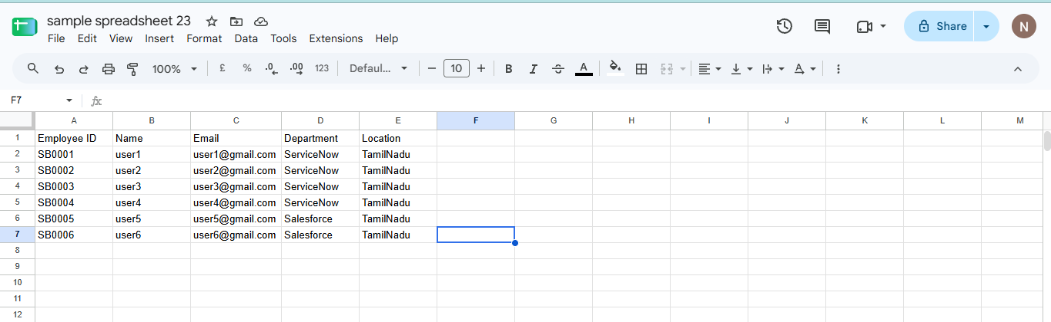

- Download the spreadsheet as Sample Spreadsheet.xlsx format.

